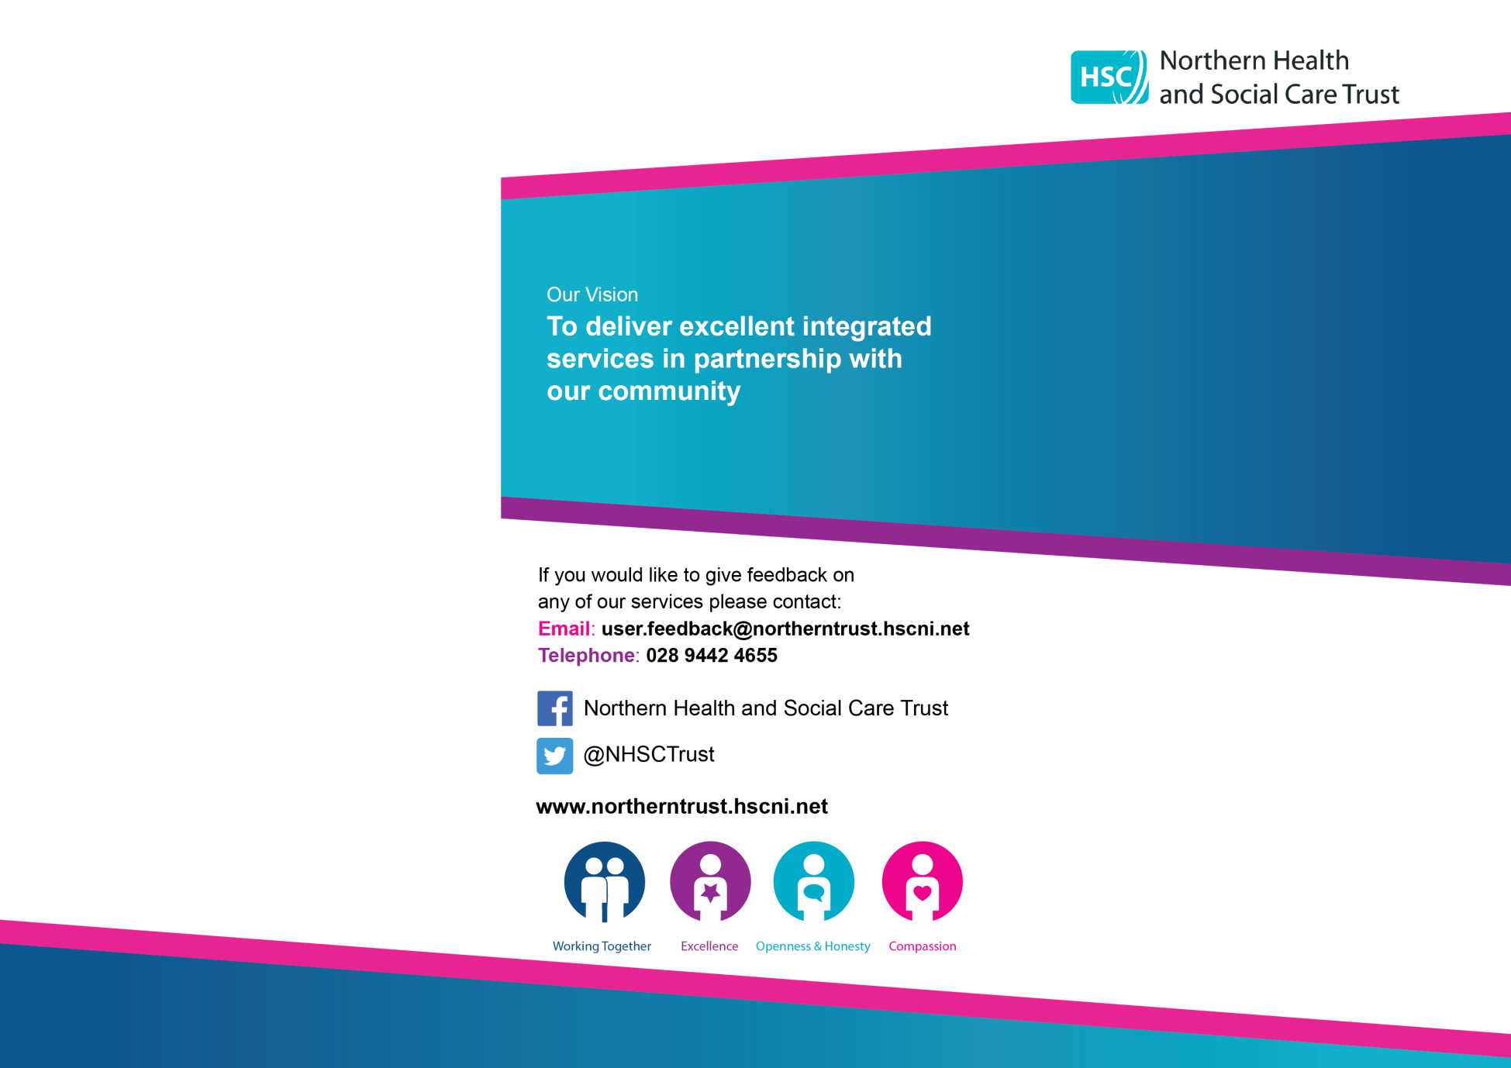

The Butterfly Group

**Support Organisations**

**SANDS** - Stillbirth and Neo-Natal Death Charity [www.uk-sands.org](http://www.uk-sands.org/)

**Tel 08081643332**

**Cruse Child Bereavement Service** – Interactive website for 12-18’s [www.hopeagain.org.uk](http://www.hopeagain.org.uk/)    
Tel 0808 808 1677  
  
**Life after Loss** - [www.lifeafterloss.org.uk](http://www.lifeafterloss.org.uk/)  
Tel 028 9260 5578

**Mariposa Trust** - [www.sayinggoodbye.org](http://www.sayinggoodbye.org/)  
Tel 0845 293 8027

**SIMBA** – [www.simbacharity.org.uk-](http://www.simbacharity.org.uk-)

Tel 0131 353 0055

**Meningitis Trust** - [www.meningitis-trust.org](http://www.meningitis-trust.org/)    
Tel 0808 801 0388

**Miscarriage Association** - [www.miscarriageassociation.org.uk](http://www.miscarriageassociation.org.uk/)    
National Helpline: 019 2420 0799, Mon-Fri 9 am - 4 pm NI Helpline 077 4099 3450  
  
**SIDS** - Sudden Infant Death Syndrome [www.lullabytrust.org.uk](http://www.lullabytrust.org.uk/) Helpline 0808 802 6868

**ARC** –Antenatal Results &Choices-[www.arc-uk.org](http://www.arc-uk.org) – Tel 08450772290/02077137486

**ANAMCARA** – [www.anamcara.ie](http://www.anamcara.ie)Tel 0852888888

**TOMMY’S –** [midwife@tommys.org](mailto:midwife@tommys.org)TEL 0800 0147800



Who are we?

The Butterfly Group has been set up within maternity services in the Northern HSC Trust. The group brings together parents who have experienced a loss (through miscarriage, stillbirth, or neonatal death) with staff to work towards improving maternity services and bereavement care for families. This is not a support group; however, some people may find that making a positive contribution to service change is helpful to them

 What do we do?

We meet to give feedback to staff and work with them to find ways to improve the service.

We are always interested to hear the views of bereaved parents-both the good experiences and the things that need to be improved on. If you would like to attend the next meeting you can contact us by telephone, email, or post



How to contact us

Lesley-Ann Kennedy,

 Bereavement Support Midwife

Maternity Unit,

Causeway Hospital,

4 Newbridge Road,

Coleraine BT521HS

 [Bereavement.SupportMidwife @northerntrust.hscni.net](mailto:Bereavement.supportmidwife@northerntrust.hscni.net)

 07585 999665

