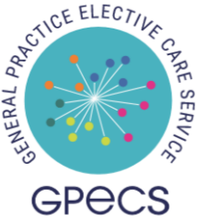
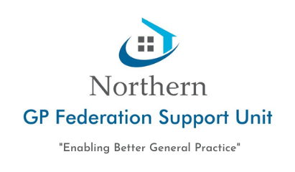

9th December 2025

Dear Applicant,

GPES/GY/12/25 – GP with Enhanced Skills (Gynae Services)

Thank you for the interest you have shown in our campaign to engage GPESs for Gynae Services within the Northern GP Federation.

We seek to resource an additional GPES’ for the following host practices within the Northern area:

- Northern GP Federation:
Glengormley Practice (3 sessions – 12hours)
Frocess Medical Centre (3 sessions – 12 hours)

Whilst we have an immediate vacancy in this area, we will be generating a waiting list for the position of GPES within the wider Northern GP Federation area.

The successful candidate will work alongside other GPESs to deliver the service. The scheduling of these clinics will be decided between the Host Practice and GPESs when allocated.

If you wish to be considered for this role, please complete the attached Expression of Interest Form return to HR via email hr@northernfsu.co.uk.

Closing date for receipt of Expressions of Interest is 12 noon on 29th December 2025.

Yours faithfully

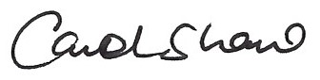
Carol Shaw
Human Resources Administrator
for Northern GP Federation Support Unit

